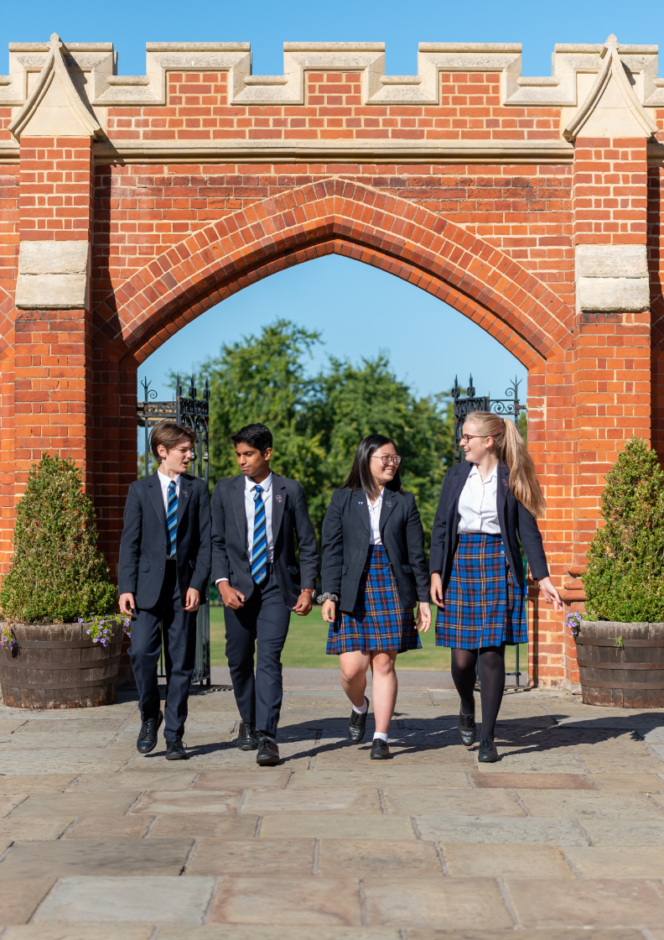
Candidate brief for the position of
Grounds Person
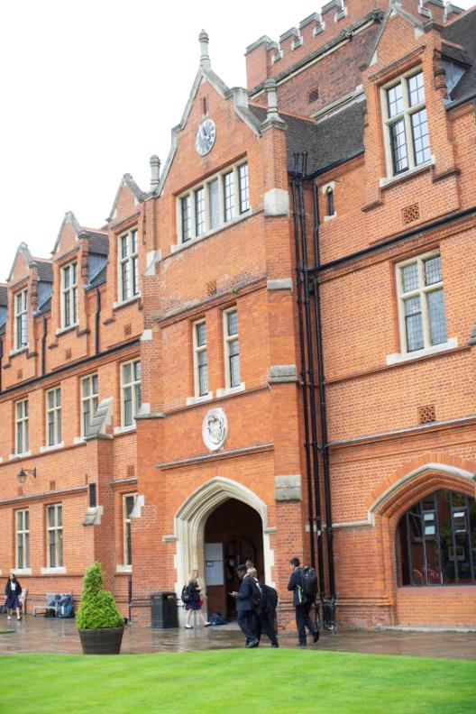

Contents

The Role

Key Responsibilities

The Person

The Department

Bancroft’s School

Working at Bancroft’s

How to Apply

The Role
The school has an extensive range of sporting facilities including cricket squares, rugby pitches, tennis courts and athletics tracks. The Grounds Person works on all sports playing fields at our main school site and West Grove playing fields. Grounds staff are also expected to undertake work in the schools gardens, borders and boundaries, ensuring these areas are maintained to a high standard.
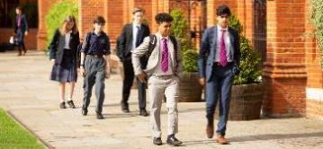
This position would suit a “hands on” experienced individual who is flexible and committed to providing quality sports spaces. The Grounds Person takes an active role whilst understanding the changes in the sporting seasons. Prioritising the day to meet the requirements of the PE department under guidance from the Deputy Head Grounds is an essential part of this role. The Grounds Person is expected to cover the West Grove grounds in the absence of the Deputy Head Grounds.

Key Responsibilities

The responsibilities of Grounds Person are:
- Daily maintenance of grounds, marking out of all sports and playing surfaces using appropriate methods and machinery
- Working closely with the PE Department
- Preparing pitches – grass cutting / line marking. Maintain cleanliness and tidiness of all external hard play areas.
- Prepare cricket strips – close mowing and scarifying
- Top dressing pitches
- Marking out and measuring running tracks / other field sports
- Use of pedestrian mowers
- Use of large equipment e.g. tractors, trailers, gang mowers, aeration machinery
- Keep grounds to a high presentation and clean standard
- Assist with upkeep of all trees and major hedges
- Application of fertilisers / nutrients and chemicals
- Identifying and controlling weeds
- Attend appropriate training courses to allow safe use of grounds equipment (if required)
- Assist in erection and dismantling of sports equipment
- Landscaping and small projects as required (grounds preparation, planting, turfing, seeding and pruning)
- Cover the Deputy Head Grounds in relation to West Grove when required
- Ensure work areas and school grounds are kept clean, tidy and secure at all times.
- Opening and closing of school premises including gates, doors, windows etc for the school use, lettings, out of hours functions, maintenance and emergency
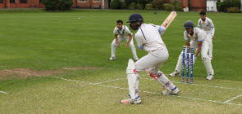

Additional Work Information
- This job description is not an exhaustive list of all responsibilities or duties but reflects the major core of the role
- The organisation reserves the right to alter the content of this job description after consultation to reflect changes to the job or services provided, without altering the general character or level of responsibility
- In the event of a major incident or disaster, you may be required to provide assistance, in whatever capacity necessary and participate in any training to ensure the School is fully prepared for such events.
- Bancroft’s School is committed to providing the best possible care and education to its pupils and to safeguarding and promoting the welfare of children and young people. The School expects all staff, contractors, Governors and volunteers to share this commitment
- To demonstrate a commitment to improving and developing the organisation’s processes and facilities
- To carry out such duties that may be reasonably required by your line manager

Safeguarding

Bancroft’s is committed to safeguarding and promoting the welfare of children and young people and expects all staff and volunteers to share this commitment. Successful candidates are required to undergo child protection screening appropriate to the role, including checks with past employers and the Disclosure and Barring Service (DBS).
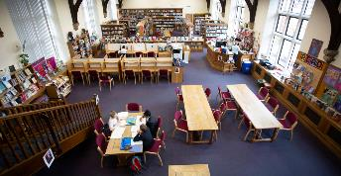

The Person
Essential Criteria
- Previous experience working in the care of sports grounds or turf care
- Full clean driving licence to include tractor driving and towing a trailer
- Work as part of a team or independently as required
- An energetic, proactive attitude
- Flexible and adaptable to changing demands and priorities
- Practical and hard working
- Confident and enthusiastic
- Working to deadlines
- Adaptive to change
- Friendly and cooperative
- A willingness to work outside in all weathers
- The ability to interpret plans and drawings
- Knowledge of Health and Safety regulations
- Safe working practices within a grounds post

Desirable Criteria
- A relevant qualification eg NVQ2 in groundsmanship
- Previous experience working within a school environment
- Chemical spraying licence
- Practical maintenance skills
- Willingness to use initiative
- Punctual
- Ability to work under pressure
- Knowledge of safeguarding

Bancroft’s School
Bancroft’s School was founded by the Drapers’ Company in 1737 on the Mile End Road as a day-school for local boys from a diverse range of backgrounds; the School has come a long way geographically and institutionally since then but remains committed to pupils from a wide range of backgrounds and has a long tradition of excellence.
We are now a co-educational independent day school for around 1200 pupils from 7 to 18 and an unashamedly aspirational school, devoted to scholarship and intellectual inquiry. We aim to provide an atmosphere in which each child can flourish and we believe that children succeed when they take full advantage of the huge range of different opportunities we provide – whether immersed in academic research, being out on the sports fields, taking part in charitable activities, acting on the stage, playing music and attending some of our numerous clubs and societies, our pupils challenge themselves and learn by taking part wholeheartedly in school life.
We have the highest expectations for every child in the School and we support, encourage and nurture each individual; we want our pupils to enjoy life to the full, make enduring friendships and grow up in a friendly, safe but challenging environment.
At Bancroft’s we continually strive to ensure that all our pupils leave here with the confidence, self-awareness and knowledge to thrive in the world beyond, as well as taking with them an awareness of others and an abiding curiosity about the world.
Bancroft’s has a selective 5 or 6 form entry at 11+, with just under half the pupils coming from the Preparatory School. The school uses its own entrance exam and admits boys and girls in equal proportions. There is a further small entry at 16+, and most pupils stay into the Sixth Form. Public examination results are very strong and place Bancroft’s among the top co-educational schools in the country.
Due to the continuing Covid-19 pandemic, students were unable to sit their GCSE and A Level examinations in June 2021. Instead they received Teacher Assessed Grades which were awarded after a rigorous review of various evidence including tests and coursework.
82.2% of all GCSEs at Bancroft's in 2021 were awarded the top grades of 9 or 8; 99.1% achieved either grades 9/8/7 with 99.8% graded as a 5 or better.
In common with the pattern across the country, the number of top A Level grades which were awarded to Bancroft's pupils increased. Bancroft’s pupils achieved 63.9% at A*; 98.1% of exams were awarded grades A* - B.
Bancroft’s is a forward-looking, modern school; a centre of excellence for the twenty-first century.

Working at Bancroft’s
The successful applicant will receive an attractive salary package according to experience and expertise. Benefits include free school lunch and refreshments during the day, private medical insurance, pension and concessionary fees for children attending the school (dependent upon academic assessment).
We have a generous CPD budget and staff are encouraged to look for opportunities to develop their skills and expertise either to further their career or to support their enjoyment of their role. We have a Staff Wellbeing Group, and an active Senior Common Room who organise a range of social events. Staff have access to various sporting facilities such as the gym and the swimming pool at allocated times. We also have a staff group working on Diversity and Inclusion and are founding members of the Schools’ Inclusion Alliance.
The hours are full time, 08:00 – 4:30 pm, 52 weeks per year, with 27 days annual leave and 8 bank holidays.

How to apply
An application form is available to download from the School website, http://www.bancrofts.org/about-us/employment-opportunities

