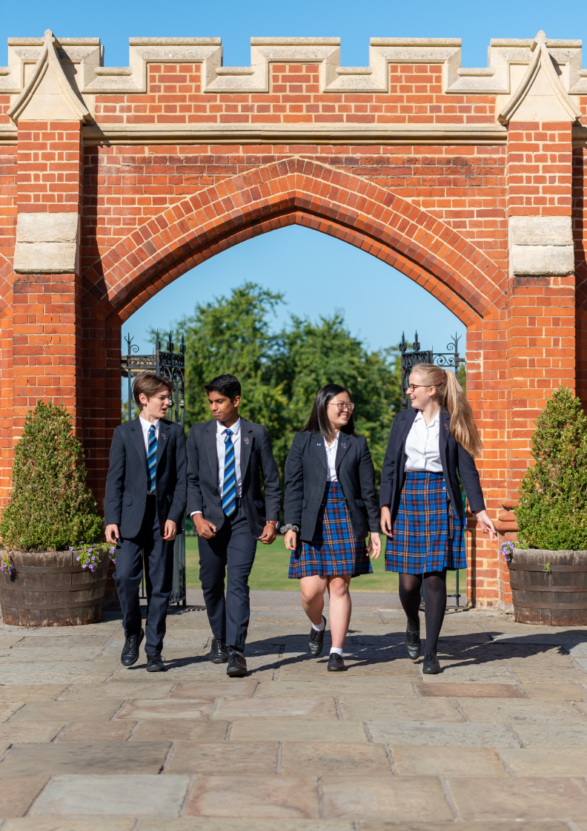
Candidate brief for the position of
Self Employed Teacher of Music (Trumpet)

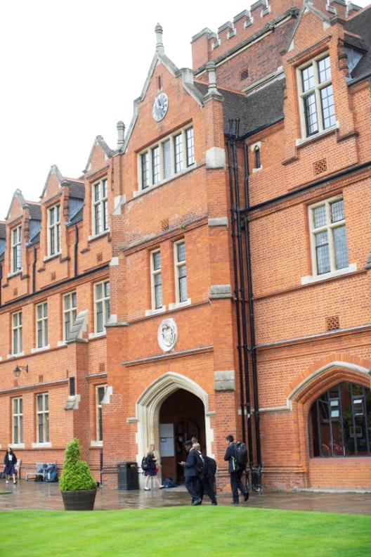

Contents

The Role

Responsibilities

The Person

The Department

Background

Remuneration

How to Apply
Bancroft’s School High Road Woodford Green Essex IG8 0RF
Senior School T. 020 8505 4821 E. office@bancrofts.org
www.bancrofts.org
Reg. Charity No. 1068532. Registered as a company in England and Wales No. 3513962

The Role

We are looking for a self-employed trumpet specialist who is able to teach trumpet to a high level.
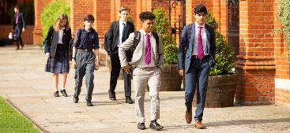

Key Responsibilities
- To deliver instrumental tuition to pupils
- To inspire pupils to develop a passion for the music they play
Responsibilities/Accountabilities:
- Signing and adhering to the “Agreement to use the facilities of Bancroft’s School for the provision of music tuition”.
- Adhering to departmental policies and to meet School deadlines insofar as it applies to the department.

Responsibilities in relation to the pupils and to what is taught:
- Teaching trumpet technique.
- Setting appropriate pieces to develop skill in young trumpet players.

- Prepare students for exams and concerts, including advice on selection of pieces.
- Monitoring the progress and learning of pupils, and liaising with parents when necessary.
- Ensuring pupils are entered for exams in accordance with departmental timescales.
- Prepare timetables on a half termly basis, ensuring that all pupils are informed of the time of their lessons well in advance. School timetables should be taken into account where possible, e.g. avoiding lessons during pupils’ games afternoons.
- Write reports on pupils as they are due, usually 1 per pupil per year, using the school reporting software.
- Encourage pupils to join groups and/or set up bands as appropriate.

Responsibilities in relation to the School:

- Carrying out School policy, including the School safety policy, in the context of the department.
- Communicating any concerns to the Head of Department.
- Invoice parents for the cost of lessons in advance of each term, and all the financial and organisational requirements as laid out in the “Agreement to use the facilities of Bancroft’s School for the provision of music tuition”.
- Comply with all the school regulations which apply to visiting staff, as set out in the staff handbook and music department handbook.
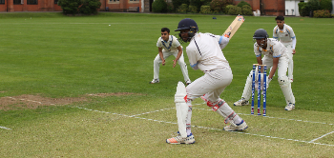

Additional Work Information

- This job description is not an exhaustive list of all responsibilities or duties but reflects the major core of the role.
- The organisation reserves the right to alter the content of this job description after consultation to reflect changes to the job or services provided, without altering the general character or level of responsibility.
- In the event of a major incident or disaster, you may be required to provide assistance, in whatever capacity necessary and participate in any training to ensure the School is fully prepared for such events.

- Bancroft’s School is committed to providing the best possible care and education to its pupils and to safeguarding and promoting the welfare of children and young people. The School expects all staff, contractors, Governors and volunteers to share this commitment.

The Person

The ideal candidate will demonstrate the following
- At least diploma level qualification in trumpet
- Experience of performing and teaching
- Ability to teach all ages from 7-18
- Competent to teach all grades up to at least grade 8
- Confident, Patient and encouraging, Diligent
- Organised, Enthusiastic
- Cooperative, Team Worker
- Understanding of and commitment to Safeguarding
- Understanding of and commitment to Health and Safety

Desirable Criteria
- Music teaching diploma
- Prior teaching experience
- High ability pupils exposure
- Practical and Creative
- IT Literate

The Department
The music department is housed in the Adams Building and has two classrooms, one of which is used as a technology area and is equipped with a suite of iMac computers running Sibelius 7 and Logic Pro 9. The main teaching room has a computer projector and twelve keyboards on class worktops.
In years 7-8 pupils are taught a broad curriculum throughout the year in classes of about 17, and in year 9 the subject is taken as an option, currently with two sets. The school follows the Edexcel specification for Music GCSE and AQA at A-level and classes in these year groups are relatively small.
The music office and practice rooms are on the top floor and this is where the team of visiting music teachers is based. These teachers are self-employed and organise their own timetables of instrumental lessons for pupils in the prep and senior schools. Some of the peripatetic staff assist with running extra-curricular music groups.
The music department has a wide range of weekly extra-curricular activities, including orchestras, choirs, bands and smaller ensembles. There are regular concerts throughout the year, ranging from informal chamber concerts to large-scale events and shows. The department is regularly involved in music for morning chapel and assemblies and there is a high-profile concert at the Drapers’ Hall in London every March.

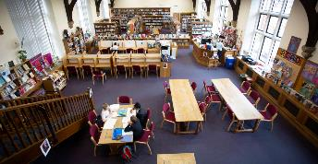

Background
The School
Bancroft’s School was founded by the Drapers’ Company in 1737 on the Mile End Road as a day-school for local boys from a diverse range of backgrounds; the School has come a long way geographically and institutionally since then but remains committed to pupils from a wide range of backgrounds and has a long tradition of excellence.
We are now a co-educational independent day school for around 1200 pupils from 7 to 18 and an unashamedly aspirational school, devoted to scholarship and intellectual inquiry. We aim to provide an atmosphere in which each child can flourish and we believe that children succeed when they take full advantage of the huge range of different opportunities we provide – whether immersed in academic research, being out on the sports fields, taking part in charitable activities, acting on the stage, playing music and attending some of our numerous clubs and societies, our pupils challenge themselves and learn by taking part wholeheartedly in school life.
We have the highest expectations for every child in the School and we support, encourage and nurture each individual; we want our pupils to enjoy life to the full, make enduring friendships and grow up in a friendly, safe but challenging environment.

At Bancroft’s we continually strive to ensure that all our pupils leave here with the confidence, self-awareness and knowledge to thrive in the world beyond, as well as taking with them an awareness of others and an abiding curiosity about the world.
Bancroft’s has a selective 5 or 6 form entry at 11+, with just under half the pupils coming from the Preparatory School. The school uses its own entrance exam and admits boys and girls in equal proportions. There is a further small entry at 16+, and most pupils stay into the Sixth Form. Public examination results are very strong and place Bancroft’s among the top co-educational schools in the country.
In 2019, following sustained application and hard work by our pupils, together with support from teachers, we saw 32.6% of all A Levels taken graded at A* with 85.2% graded A*, A or B. Results in Art, Spanish, Electronics, History and Mathematics were all particularly pleasing.
GCSEs were also a reflection of the hard work and dedication of our pupils and their teachers. Again Bancroftians rose to the challenge of restructured and more demanding examinations. This year we saw almost 65% of all examinations being awarded either an 8 or 9 (equivalent to an A*); with 99.1% of exams achieving grades 9-5.
Bancroft’s is a forward-looking, modern school; a centre of excellence for the twenty-first century.

How to apply

An application form is available to download from the School website, http://www.bancrofts.org/about-us/employment-opportunities or by emailing recruitment@bancrofts.org

Bancroft’s School is an Equal Opportunities employer and is committed to safeguarding and promoting the welfare of children and applicants will be required to undergo child protection screening appropriate to the post, including checks with past employers and the Disclosure and Barring Service.

